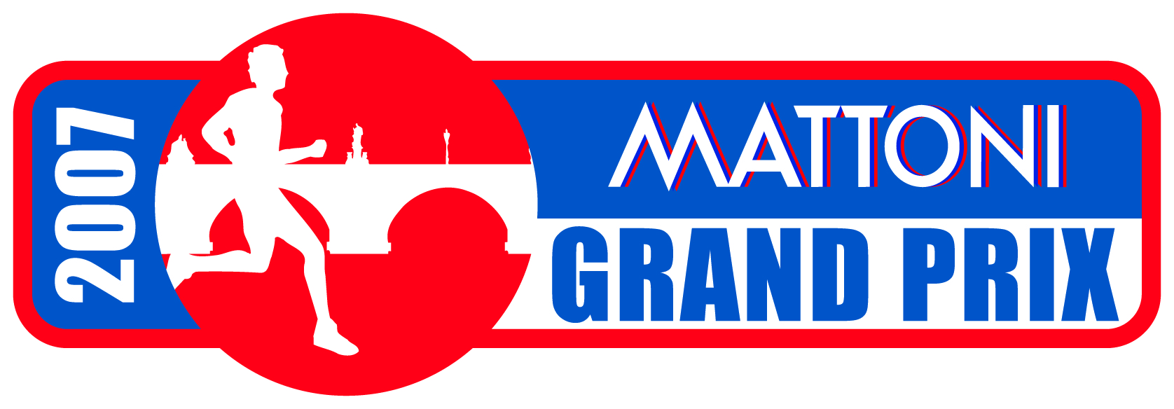

START LIST
10 Km Metro Men’s Race

BIB Nat. Name Surname Birth PB 10 Km Club/Sponsor
PB 10000 m

 1 KEN WILFRED KIPKOECH TARAGON 1985 27’30’’ adidas
2 KEN DAVID KIPKORIR CHELULE 1977 27’32’’ Nike
3 KEN PATRICK KIMELI 1989 27’35’’ adidas
4 KEN SAMWEL RONGO OLENGURA 1972 27’41’’ Nike
5 KEN JOHNSTONE CHEPKWONY 1984 28’10’’ adidas DNA
6 KEN JUSTUS KIPCHIRCHIR KIPRONO 1987 28’17’’ adidas
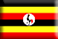 7 UGA GEOFFREY KUSURO 1989 28’17’’ adidas
 8 ITA MOSTAFA ERREBBAH 1971 28’30’’ adidas
9 KEN JOHN WAMAI KAMINDO 1983 29’05’’ adidas
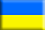 10 UKR DMYTRO LASHYN 1988 29’51’’ adidas
 11 PER VLADIMIR ESCAJADILLO 1981 31’56’’ BAV
 12 TAN PASCAL SARWAT 1989 debut Brooks
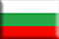 13 BUL IVAN ČOTOV 1970 debut -
14 TAN PAUL GASHI 1990 debut Brooks
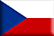 15 CZE PAVEL NOVÁK 1970 debut Atl. Jihlava
16 KEN JULIUS MAINA 1977 27’41’’ adidas

START LIST
5 Km adidas Women’s Race

BIB Nat. Name Surname Birth PB 5 km Club/Sponsor
PB 5000 m

F1501 KEN IRENE KIPCHUMBA KWAMBAI 1978 14’49’’ Reebok
 F1502 ETH BIZUNESH BEKELE 1983 15’02’’ Nike
F1503 KEN SUSAN J. KURUI 1980 15’23’’ asics
F1504 UKR OXANA SKLYARENKO 1981 15’54’’ adidas
F1505 CZE PETRA KAMĺNKOVÁ 1973 16’03’’ AK Olomouc
F1506 CZE JANA KLIMEŠOVÁ 1970 16’39’’ USK Praha
F1507 CZE IVANA SEKYROVÁ 1971 17’44’’ AK Sokolov
F1508 CZE LUCIE SÁROVÁ 1988 debut TJ NMN
F1509 ETH ISRAEL MELKAMU HAILEYESUS 1981 debut Nike
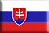 F1510 SVK DANA JANEČKOVA 1973 debut adidas

DNA: Not attending the race

Race Director - Elite Athletes co-ordinator:
Paolo Ottone
e-mail: ottone@pim.cz
mobile: +420 603 322 202 (Czech Rep.) - +39 348 006 5427 (Italy)

